Civil war in Somalia

UNSC Resolution: | 767
Date of adoption: | 24-Jul-1992
Operative paragraph: | 15
Demand number: | 767,1511

Sarah-Myriam Martin-Brûlé

Wording of demand

allow them full freedom of movement and all necessary facilities

List of addressees of the demand
- Government of Somalia, United Somali Congress Faction

Short-term compliance

Description of the addressee(s)’ conduct

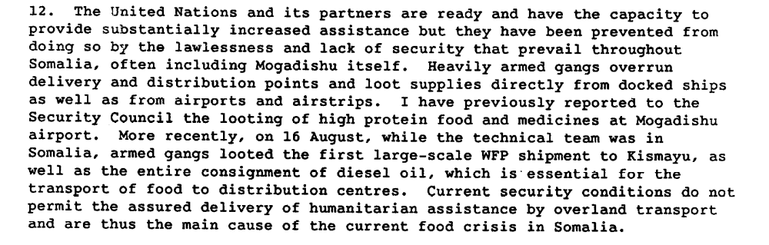

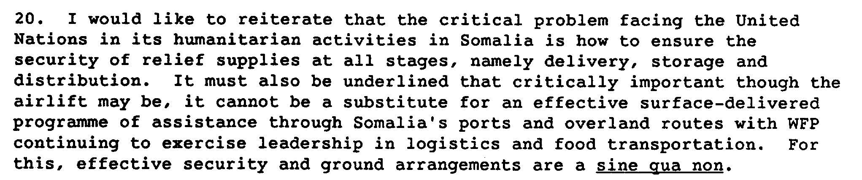

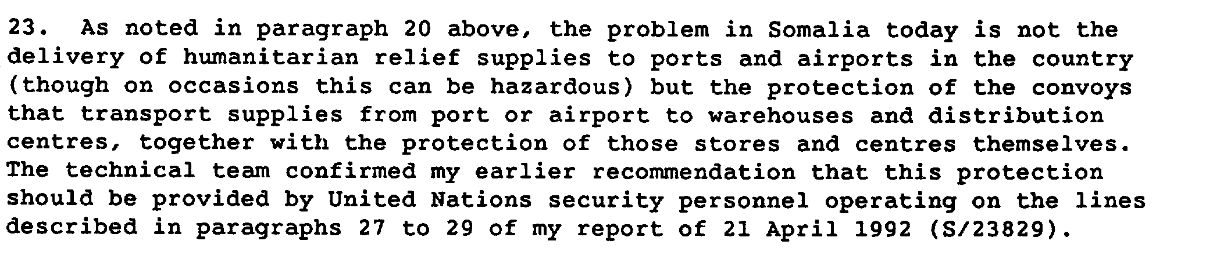

Report to the Secretary-General on the Situation in Somalia, S/24480

Assessment

Short-term compliance
No or marginal compliance (1) | X Medium low compliance (2) | Medium high compliance (3) | Full or almost full compliance (4)

Considerations underlying the assessment

The parties complied minimally to the demand for full freedom of movements of the UN personnel and associated humanitarian NGOs..

Medium-term compliance

Description of the addressee(s)’ conduct

The Secretary-General stated that a number of factors had inhibited the distribution of food and other humanitarian assistance, especially in areas outside Mogadishu. He referred, in particular, to the lack of a government or governing authority capable of maintaining law and order, to the failure of various factions to cooperate with UNOSOM, to the extortion, blackmail and robbery to which the international relief effort was subjected, and to repeated attacks on the personnel and equipment of the United Nations and other relief agencies. The net result was that, while massive amounts of relief supplies had been readied for the implementation of a 100-day action programme, the assistance reaching the intended beneficiaries was often barely a trickle. The Secretary-General insisted that, unless the problems relating to security and protection of relief were effectively addressed, United Nations agencies and non-governmental organizations would not be able to provide the relief assistance urgently in the amounts needed now in Somalia. To establish security conditions that would permit the distribution of relief supplies, it was of the utmost importance that the four additional UNOSOM battalions be deployed to Somalia as quickly as possible. However, the Secretary-General stated that, despite the intensive efforts of his Special Representative, it had been possible to secure Somali consent to the deployment of only one battalion in one part of the country. He concluded by stating that he was giving urgent consideration to the current state of affairs, and that he did not exclude the possibility that it might become necessary to review the basic premises and principles of the United Nations effort in Somalia.

Repertoire of the Practice of the Security Council, 1989-1992, “The Situation in Somalia”
http://www.un.org/Depts/dpa//repertoire/89- 92/CHAPTER%208/AFRICA/item%2006_Somalia_.pdf

Assessment

Medium-term compliance
X No or marginal compliance (1) | Medium low compliance (2) | Medium high compliance (3) | Full or almost full compliance (4)

Considerations underlying the assessment

Within the two years following the adoption of the resolution, the parties did not comply to the demand for full freedom of movements of the UN personnel and associated humanitarian NGOs. The armed gangs associated with each party continued banditry, looting and targeting of humanitarian goods and personnel.

Depth of demand

Assessment

Level of depth of demand
Low depth of demand (1) | X Medium depth of demand (2) | High depth of demand (3)

Considerations underlying the assessment

Given the insecurity of the setting and the absence of guarantee that the other demand addressee would also comply with this demand, cooperation with UN officials (and hence, restrain in using force against their adversaries) could have made it much more difficult for the demand addressee to win the civil war or gain power in its aftermath.

Level of confidence about coding decision
Extremely high | X High | Moderate

Comments to IPI (if any)

